Short Questions
SSICTC1107_03A001E, 6
1. | Jimmy is creating a diary application for users to save their diaries on their phones.  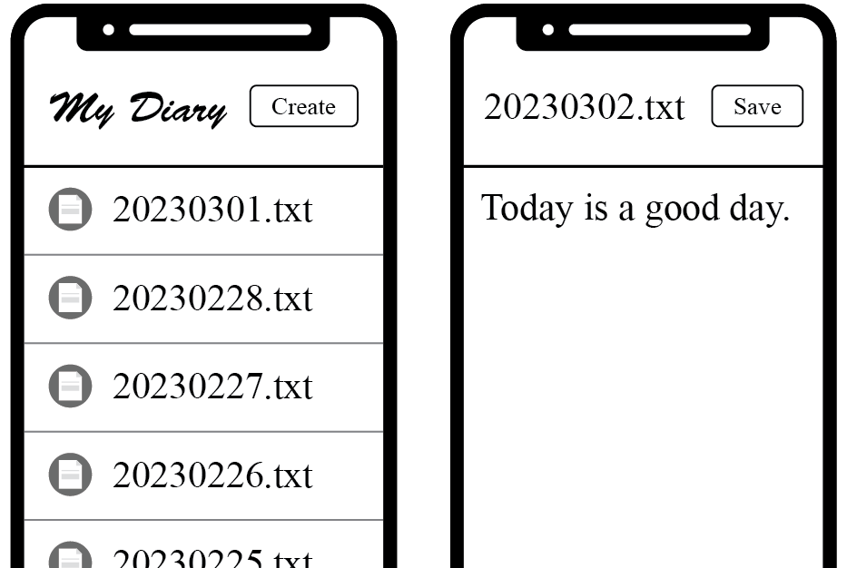
 | (a) | A few sub-programs are created to return information of the current date as strings. For a day or month with a numerical value smaller than 10, a leading zero is added to the return value. The following are the sample outputs of the sub-programs:  Sub-program Current date Return value  current_day() 31 December 2022 31  current_month() 4 May 2021 05  current_year() 6 June 2022 2022  If the current date is 2 March 2023, what will be the return values of the sub-programs? (3 marks)  Sub-program Return value  current_day()  current_month()  current_year()
 | (b) | When the user clicks on the “Create” button, a blank text file named as the current date will be created. Jimmy writes a sub-program today_diary() in Python to return the full file name of the file created. For example, if the current date is 2 March 2023, the sub-program will return "20230302.txt". Complete the sub-program for him. (1 mark)  def today_diary():  filename = ________________________________________  return filename
 | (c) | When the user has finished writing the diary, they can click the “Save” button and the inputted content will be written into the text file. Complete the following sub-program save_diary(text) for the user to save the completed diary. (2 marks)  def save_diary(text):  f = open(_______________, ___)  _______________  f.close  text = input("Write something: ")  save_diary(text)

[--Answer:
(a)
02
03
2023
(b) current_year() + current_month() + current_day() + ".txt"
(c)
today_diary(), "w"
f.write(text)
--]

Long Questions
SSICTC1107_04A001E, 11
1. | Sally is writing a program for a game, which is about guessing letters in the word given by the computer. She needs to read a text file called “dictionary.txt” in the program for choosing a random word from the following list.  hospital  orange  obsidian  dragon  water
 | (a) | Complete the following sub-program getWords() in Python to save the words in “dictionary.txt” as a list wordlist. (2 marks)  wordlist = []  def getWords():  global wordlist  f = open(___________________, ___)  word = f.readline()  while ____________________:  word = word.replace("\n", "")  wordlist = wordlist + [word]  word = f.readline()  f.close()
 | (b) | All the words have been stored in list wordlist. Given that the function randint(a, b) in the random library returns a random integer from a to b. Complete the following Python program to draw a word from the list and save it in a variable w. (2 marks)  import random
 | (c) | The word for guessing will be converted to a string of asterisks of the same length, and this string will be printed when the game starts. For example, if the word for guessing (w) is “water”, the following is displayed at the beginning of the game:  The word for guessing: *****  Complete the following Python program to hide the letters in the word for guessing and print the converted string. (2 marks)  hidden = ""  print("The word for guessing: ", hidden)
 | (d) | The player can enter a letter in each guess. If the letter exists in the word for guessing, a sub-program changeHidden(char) will reveal that letter so that the player can continue to guess the remaining letters.  The following are the sample input and output of the main program of this game, and the text in bold represents the user input:  The word for guessing: *****  Enter a letter: e  Correct! The word for guessing: ***e*
 |  | (i) | Assume the word for guessing is “water” and the initial value of hidden is “***e*”.  What should be the value of variable hidden after calling changeHidden("a")?  (1 mark)  ____________________________________________________________________________
 |  | (ii) | Assume the user input is always valid, complete the following sub-program changeHidden(char) to reveal the letter that the player has guessed correctly.  (4 marks)  def changeHidden(char):  global hidden  pr_hidden = hidden  hidden = ""

[--Answer:
(a)
"dictionary.txt", "r"
len(word) > 0
(b)
i = random.randint(0, len(wordlist)-1)
w = wordlist[i]
(c)
for i in range(0, len(w)):
hidden = hidden + "*"
(d)(i) *a*e*
(d)(ii)
for i in range(0, len(w)):
if w[i] == char:
hidden = hidden + char
else:
hidden = hidden + pr_hidden[i]
--]

